MAJOR PROJECT - 1
PHISHING AWARENESS SIMULATION USING SOCIAL ENGINEERING TECHNIQUES

1. INTRODUCTION
Phishing attacks are one of the most common and effective cyber threats in today’s digital world. Unlike technical attacks that exploit system vulnerabilities, phishing relies on social engineering techniques to manipulate human behavior. Attackers deceive users into revealing sensitive information such as usernames, passwords, and financial details by impersonating trusted organizations.
With the increasing use of emails, online banking, and cloud services, phishing attacks have become more sophisticated and difficult to identify. This project focuses on simulating a phishing attack in a controlled and ethical environment to understand how such attacks operate and to raise awareness about phishing threats among users.

2. PROBLEM STATEMENT
Many users fall victim to phishing attacks due to lack of cybersecurity awareness and inability to distinguish between legitimate and fraudulent online communications. Organizations continue to face data breaches and financial losses because users unknowingly share their credentials on fake websites. This project aims to demonstrate how phishing attacks work and highlight the importance of user awareness as a key defense mechanism.

3. OBJECTIVES OF THE PROJECT
The main objectives of this project are:
- To understand common phishing techniques used by attackers
- To simulate a phishing login page using HTML and CSS
- To study how phishing pages are designed to look legitimate
- To analyze the risks associated with phishing attacks
- To suggest preventive measures against phishing threats

4. TOOLS USED
The following tools and technologies were used in this project:
- HTML – To design the structure of the fake login page
- CSS – To style the page and make it appear realistic
- Web Browser – To execute and test the phishing simulation
- Operating System (Windows) – Development environment

5. METHODOLOGY
The project was carried out using a step-by-step approach:
- Studied real-world phishing attack examples and login page designs
- Created a basic phishing login page using HTML
- Enhanced the design using CSS to improve visual appearance
- Executed the phishing simulation locally in a browser
- Captured screenshots of the simulated phishing pages
- Analyzed how design improvements increase user trust
This simulation was conducted strictly for educational and awareness purposes, without collecting or storing any real user data.

6. SIMULATION DESIGN
The phishing simulation consists of two login pages:
- Basic Login Page:
A simple login form containing username and password fields, demonstrating how even minimal design can deceive users.
- Enhanced Login Page:
A visually improved login page styled using CSS, including centered layout, buttons, and background design to appear more legitimate.

The phishing simulation was designed to function entirely on the client side without any backend processing to ensure ethical execution. The login forms do not capture, store, or transmit any user credentials, and the simulation was executed locally using a web browser. This controlled approach allows the demonstration of phishing techniques while maintaining user privacy and adhering to cybersecurity best practices.
Figure 1 shows the basic phishing login page created using HTML.

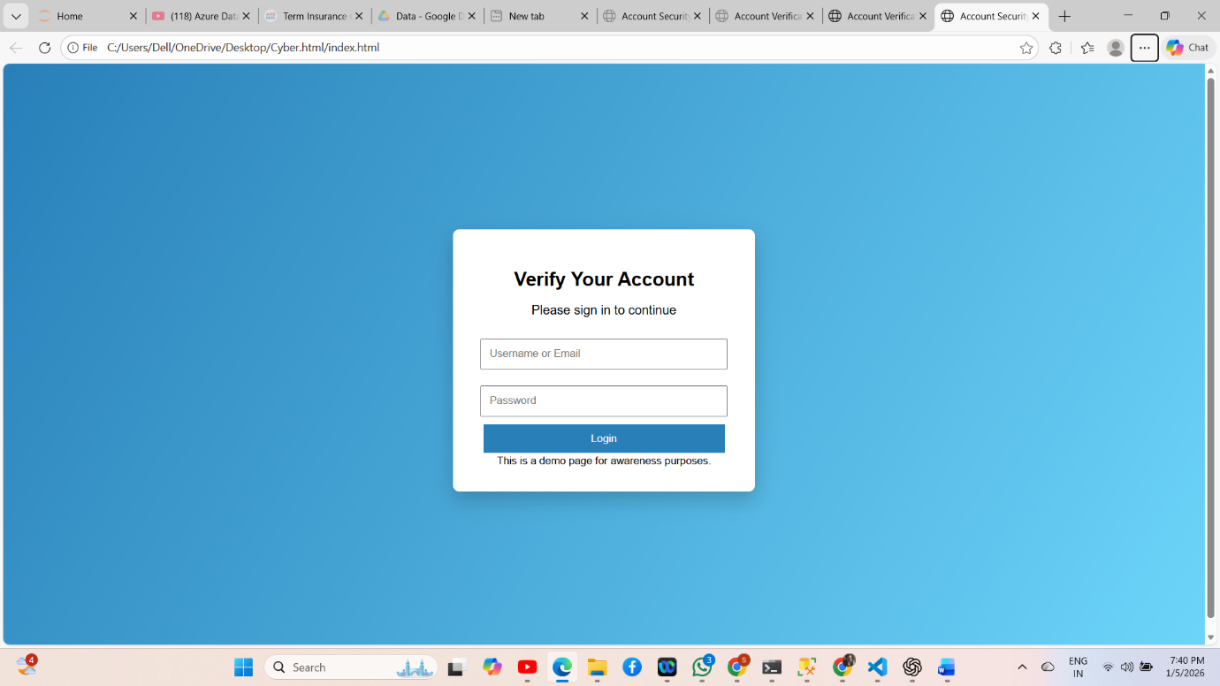

Figure 2 shows the enhanced phishing login page styled using CSS to increase realism and credibility.

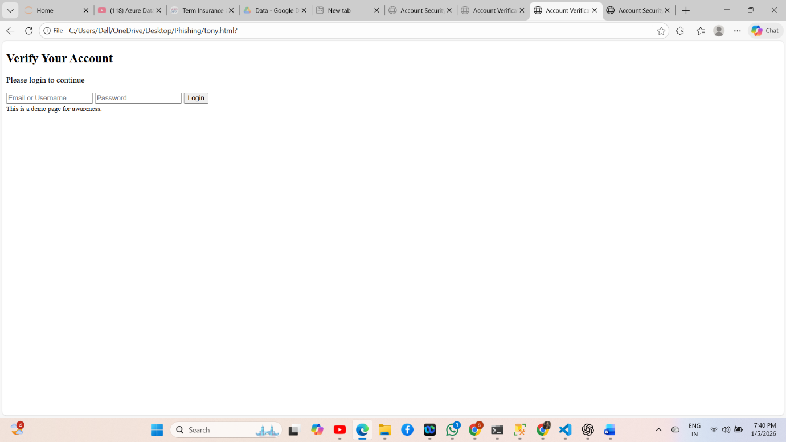
7. RESULTS AND ANALYSIS
The simulation demonstrates that phishing pages do not require advanced programming to deceive users. Even simple designs can be effective, while visually enhanced pages significantly increase the likelihood of user trust. This highlights that human behavior is often the weakest link in cybersecurity.
The project shows how attackers rely on design, urgency, and familiarity to trick users into entering their credentials on fake websites.

8. PREVENTIVE MEASURES
To prevent phishing attacks, the following measures are recommended:
- Regular cybersecurity awareness training for users
- Verifying website URLs before entering credentials
- Avoiding clicking on suspicious links in emails
- Implementing Multi-Factor Authentication (MFA)
- Using email filtering and spam detection systems

9. ETHICAL CONSIDERATIONS
This project was conducted strictly for educational purposes. No real user credentials were collected, stored, or misused. The phishing simulation was executed locally and did not involve real-world attacks, ensuring compliance with ethical and legal standards.

10. CONCLUSION
This project successfully demonstrated how phishing attacks exploit human psychology through social engineering techniques. By simulating phishing login pages, the project highlights the ease with which attackers can create deceptive websites and the importance of user awareness in preventing cyber threats. Educating users remains one of the most effective defenses against phishing attacks.

11. FUTURE SCOPE
Future enhancements to this project may include:
- Adding phishing email simulation
- Tracking user interactions for awareness studies
- Integrating phishing detection mechanisms
- Using machine learning for phishing identification

12. REFERENCES
- Phishing awareness and cybersecurity guidelines
- Social engineering attack studies
- Web security best practices

